PRE & POST PROMOTION GUIDE

OVERVIEW

We encourage you to follow this promotional plan for the highest level of success with your live stream event:

- First, add a Kick-Off Post 3-5 days out from your live stream.
- Second, add a Promotion Post before your live stream session with Justin.
- Third, re-purpose your replay once the live stream is over.

KICK-OFF PROMOTION

We recommend you start promotions 3-5 days before your live stream. Sample imagery to go with the post below can be found at: https://justindonald.com/live-stream-co-host/

I'm extremely honored and proud to show support for Justin Donald and his journey to help business professionals and entrepreneurs reach financial freedom through low-risk cash flow investing.

If you’re a business professional or entrepreneur, I bet you have thought about reaching financial freedom. Think about it - finally supporting yourself and your family through passive income alone: no job, just investments! That is why Justin has written his new book, The Lifestyle Investor. His innovative mindset principles and 10 commandments of Lifestyle Investing have released scores of entrepreneurs from the “golden handcuffs” that come with running life-consuming enterprises.

On [date and time] I will be going LIVE on Facebook with Justin to share some of the best nuggets in The Lifestyle Investor - You won’t want to miss the information we’re going to share.

Join us here ---> [link to your FB profile]

Justin has been called the “Warren Buffett of Lifestyle Investing.” He is a lifelong leader and trainer with a track record of achievement. He will open your eyes to the world of cash flow investing by teaching you investment systems in a way that actually makes sense. Justin is a master of low-risk cash flow investing, specializing in simplifying complex financial strategies, structuring deals, and disciplined investment systems that consistently produce profitable results.

[your name here]
#TheLifestyleInvestor @JustinDonald

PRE-SESSION PROMOTION

This is the social media content you’ll want to post before your session (edit to make your own). Sample imagery to go with the post below can be found at https://justindonald.com/live-stream-co-host/

I am thrilled to join forces with Justin Donald to help spread his message to the world! Justin’s passion is to help business professionals live a life of financial freedom generated through passive income.

There is a ton of investing noise out there right now and we know it can be difficult to know where to start. Justin Donald is here to help YOU wade through the investing mud and give you the tools you need to reach what you’re striving for - a life of fulfillment and abundance!

On [date] at [x:xx Eastern] I will be LIVE with Justin Donald to discuss his new book, The Lifestyle Investor, releasing on December 8th.

More about Justin:

Justin has been called the “Warren Buffett of Lifestyle Investing.” He is a lifelong leader and trainer with a track record of achievement. He will open your eyes to the world of cash flow investing by teaching you investment systems and in a way that actually makes sense. Justin is a master of low-risk cash flow investing, specializing in simplifying complex financial strategies, structuring deals, and disciplined investment systems that consistently produce profitable results.

Join us and PLEASE.... share this post for me so we get more views and therefore can help a LOT more people!!

- - - - - -

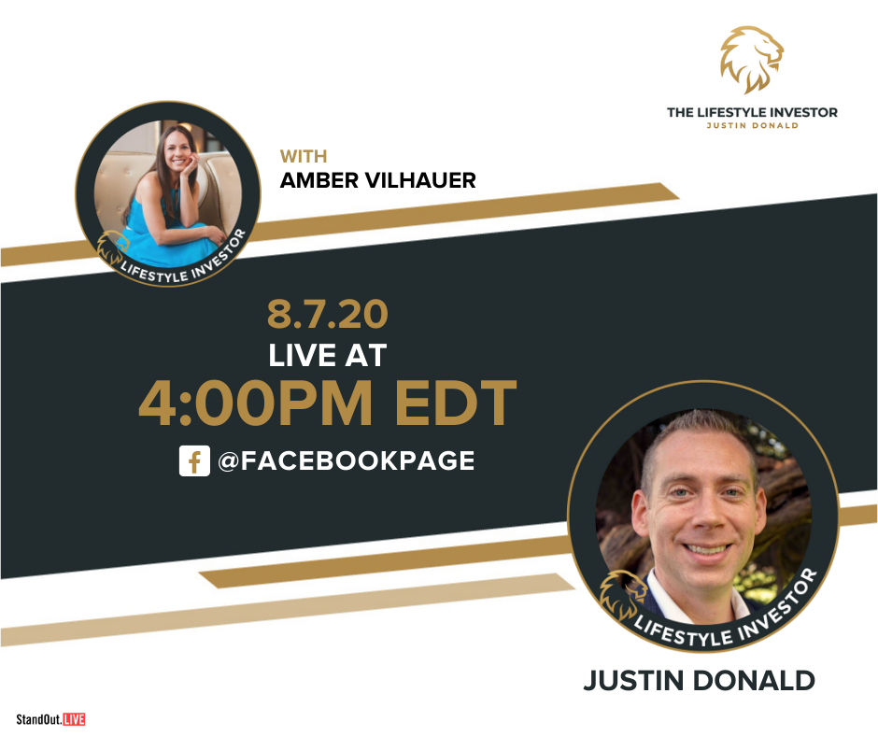

POST-SESSION PROMOTION

Once you end the Zoom live stream, your live stream will now be automatically converted into a replay video on your Facebook page or Group. These are the steps we live to take after a live stream is over:

- Update your Facebook description. Inside of Facebook, click Edit for the post of your video session. Then add a new, more compelling description of what was discussed, why someone should listen to the replay, and don’t forget to include a call to action! Here are some examples:
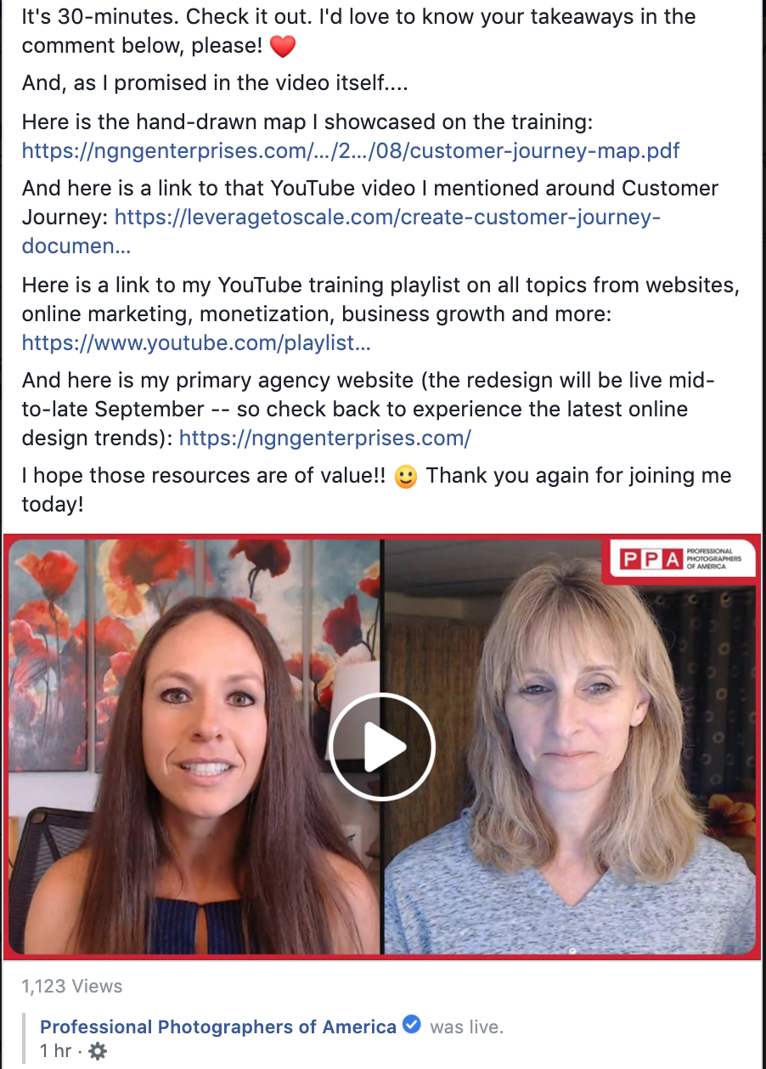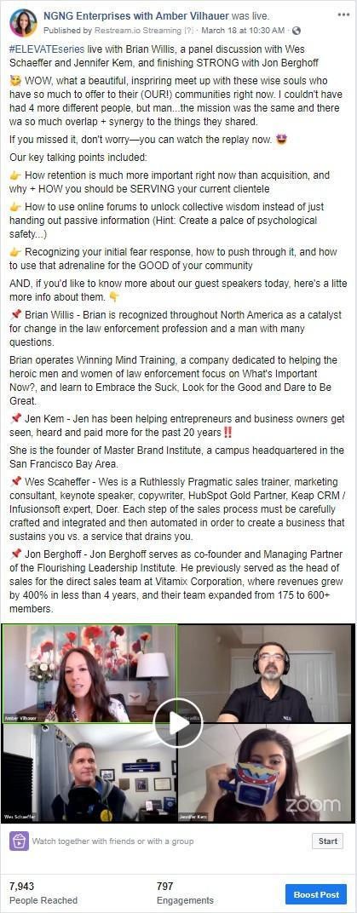
- Download and Repurpose Your Live Stream. We suggest:
  - Download the video replay from Facebook
  - Add titles/tags/custom thumbnail images
  - Upload the video to YouTube
  - Share the video with your email list
  - Embed the video into a blog post
  - Share the replay with your session guest if you had one and ask them to promote it.
  - (train your team how via a SocialMediaExaminer blog post)

