TECHNICAL GUIDE TO LIVE STREAMING

OVERVIEW

There are lots of ways you can live stream into Facebook (and/or other platforms).

The popular video conferencing platform Zoom allows you to live stream directly into Facebook, YouTube or both by using a custom live streaming service such as Restream.io or Streamyard.

Other options you could pursue are going live directly out of the Facebook app itself, eCamm Live, Crowdcast.io and others. Additionally, you could live stream directly into YouTube, LinkedIn (though you’ll need to apply first), and Instagram.

To keep things easy, this training focuses on how to live stream via Facebook only, using Zoom.

PREREQUISITES

Here’s what you need to do in order to broadcast Live on Facebook:
- Have a Facebook page
- Invest in a Zoom Account
- Enable Live Stream on Facebook

STEP 1. ENABLE LIVE STREAMING
IN ZOOM: ACCOUNT LEVEL
To enable all members of your organization to live stream meetings on Facebook:
- Sign in to the Zoom web portal as an administrator with the privilege to edit account settings.
- Click Account Management > Account Settings.
- Toggle the Allow live streaming the meetings under In Meeting (Advanced), and enable Facebook.
- (Optional) If you want to make this setting mandatory for all users in your account, click the lock icon, and then click Lock to confirm the setting.

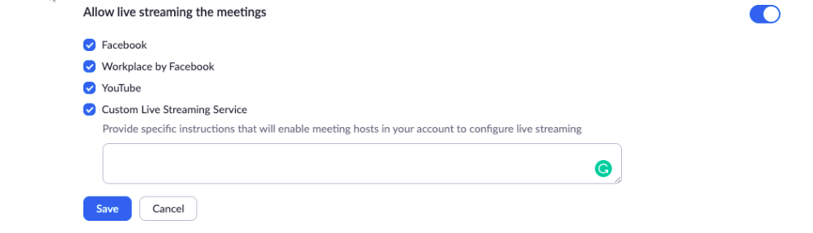
IN ZOOM: USER LEVEL
To enable live stream the meetings that you host on Facebook:
- Sign in to the Zoom web portal.
- Click Account Management > Account Settings (if you are an account administrator) or Settings (if you are an account member).
- Toggle the Allow live streaming the meetings under In Meeting (Advanced), and enable Facebook.
- Note: If the option is grayed out, it has been locked at either the Group or Account level, and you will need to contact your Zoom administrator to make changes.

IN FACEBOOK: PAGE PERMISSIONS
You must be an admin or an editor to stream to a Facebook page. If you are a moderator, analyst or advertiser, this page will show up under your Facebook pages, but you will not be able to Live Stream.
- Log in your Facebook account.
- Click the arrow at the top right and choose the page you would like to stream to.
  - If the page is not listed, click Manage Pages and then click the name of the page.
- Click Settings.
- Click Page Roles on the left.
- Under Existing Page Roles, it will list anyone who is assigned a role for this page and their role. Only admins and editors can stream to a page.
IN FACEBOOK: GROUP PERMISSIONS
You must have admin permissions for a group to stream. If you have moderator or member permissions, you will not be able to live stream to this Facebook Group.
- Log in to your Facebook Account.
- Click Groups on the left side.
- Under Groups You Manage, click the gear next to the group you would like to stream to and click Edit Group Settings.Note: If the group appears under Your Groups, not Groups You Manage, you are a member of this group and will not be able to live stream.
- Click Members on the left.
- Under Admins and Moderators, click ... next to your name.
  - If you are a moderator for the group, you will have the option Remove as Moderator. You will not be able to live stream.
  - If you are an admin for the group, you will have the options Change to Moderator and Remove as Admin. You will be able to live stream.

STEP 2. START A LIVE STREAM
IN ZOOM: ACCOUNT LEVEL

Direct Streaming From a Meeting or Webinar
- Start your normal Zoom meeting.
  - Going live with multiple guests? Wait until your guests all arrive, then initiate the same steps below.
- In the control bar, click More.
- Click Live on Facebook.
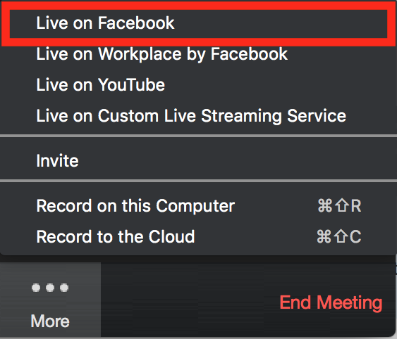
- Your default browser will open and you will be prompted to log into Facebook if you aren't already logged in.
  - Log into Facebook using either your email address or phone number and your password.
- Choose where on Facebook you would like to Go Live.
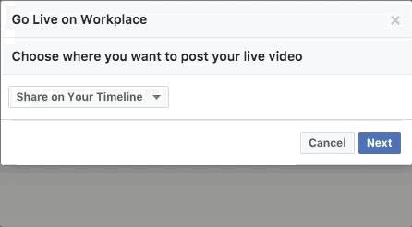
- Click Next.
Note: If you are not able to start the live stream, clear your browser's cache and cookies, then try again.
- When you are ready to start the broadcast on Facebook, click Go Live.
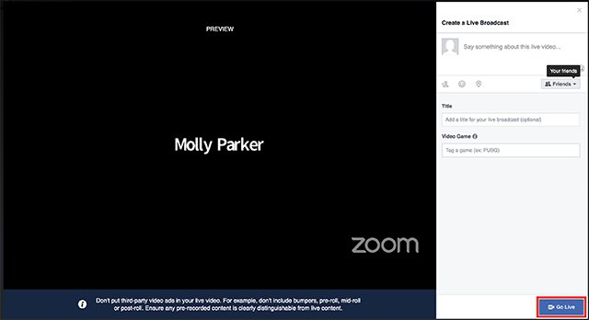
- Wait for the notification from the Zoom client that you are Live on Facebook, then begin your live stream.
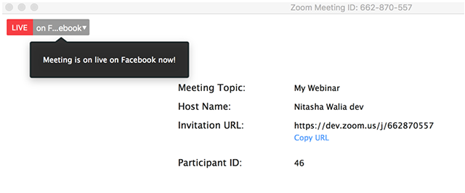
- Streaming stops if you click the More icon in the control bar, and click Stop Stream OR when you end the meeting. You will notice the read LIVE icon in the top left of your screen will go away as confirmation.

DEBRIEF

Your live stream will now be automatically converted into a replay video on your Facebook page or Group. Follow the Post Promotion Guide next.

